E4S KS1 Keeping safe and risks – Feeling safe

Cornerstone: | PHWB
Concept: | Keeping safe and risks
Theme: | Feeling safe
Key Questions: | Teachers have used the questions and statements from the E4S curriculum to plan lessons on being safe, which are delivered throughout the year according to the school’s scheme of work.  This is what your child will be learning about in the upcoming scheme of work:  - What does it feel like to feel safe/ unsafe?  - How do we keep safe?  - What do we think we have to keep safe from and how do we do this?  - Who are the people who keep us safe and what do they do?  - How can we help them to keep us safe?  - Who can we ask for help?  - How do we know whom to ask for help?  - What safety choices do we make daily?  - How does it feel when we make these choices?  - How could someone deal with a situation where they feel unsafe or there is danger?
Questions to consider with your child: | What makes you feel safe?  What makes you feel unsafe?  What feelings do you have when you feel safe or unsafe?  Who helps to keep you safe?  What can you do to keep yourself safe in different situations (e.g. by the road, at home, at school, at the park, near water, at the shops etc.)  Who can you ask for help if you feel unsafe?
Suggested Resources for parents: | Please find additional support and guidance below in relation to feeling safe.  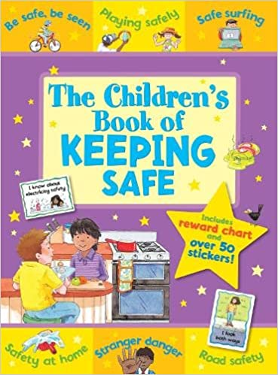  UK Safer Internet Centre  Clever Never Goes  Online Safety Games  BBC Bitesize - How to be safe  The Children's Book of Keeping Safe

