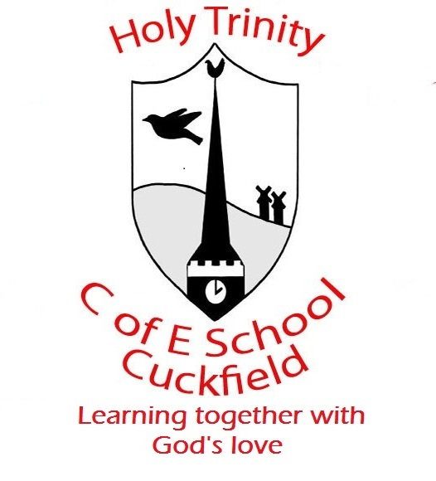 Update from Reception Week 6 (Spring)

Week Beginning- Spring 2020, week 6, 10.2.20
Last week the children enjoyed finding out about India. They did some fantastic writing about what animals they would find in the jungle. It was great to see how much progress so many of the children have made with their phonics and writing. We all enjoyed tasting traditional Indian cuisine.
This week we are continuing to focus on India and ‘No Dinner’. The children will be freeze framing some scenes from the story, as well as writing group poems about animals in the jungle.
In maths we will be focusing on repeating patterns. The children will be continuing patterns, talking about the patterns and creating their own using colours, shapes and any resources they choose. The children will also have the opportunity to explore a problem solving activity using the colours from the Indian flag.

Many Thanks for your help and support
The Early Years Team

