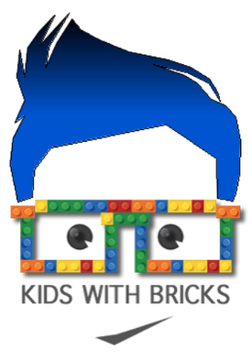

Dear Parents,

***Kids With Bricks After School Club- Holy Trinity Primary School***

We are pleased to be able to offer a new Kids With Bricks after school club running from **15:30-16:15** every **Wednesday** for **10 weeks from 15th January 2025.** This club is open for **Years 1-4** and there are a maximum of 20 places available. The club is organised, administered and supported by Kids With Bricks Ltd, an external provider who deliver after school clubs across the whole of the UK.

As well as completing a range of exciting educational challenges, students will have the chance to work both individually and to work in teams.

As an added bit of fun, students from the club will also take part in a weekly inter-school competition where parents can vote for their favourites and points are won for the national leader board.

**BOOK ONLINE!**

The club costs £3.99 +VAT per child per session and is paid for termly in advance. All club places are reserved and paid for online. Just go to [**www.kidswithbricks.com**](http://www.kidswithbricks.com/)to book your child’s place.

**Tickets are live on our website from Monday 25th November at midday**

**Any problems please contact us at**  **bookings@kidswithbricks.com**

Kind regards,

***John Gallacher***