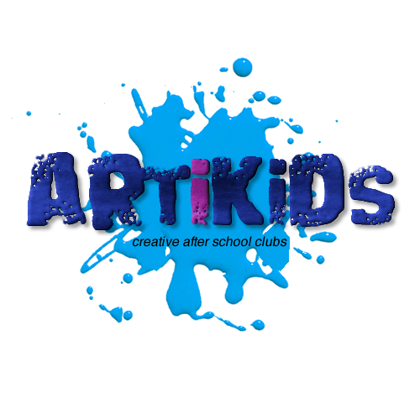

Dear Parents,

***Artikids After School Club at Holy Trinity Primary School***

We are excited to be able to offer a new and very popular arts & crafts after school club running from **15.15-16.15** every **Tuesday** for **10 weeks from 14th January 2025.** This club is open to **Years 1-2** and there are a maximum of 15 places available.

The students will have the opportunity to develop their creative talents through not just drawing, painting and design but also work with arts and crafts materials to produce everything from Egyptian Scarab Beetles to Attacking Aliens!

Each term the students are going to learn about a range of new topics through exciting videos produced specifically for this course. They will also get to use a huge array of crafty resources that have been supplied to the school specifically for this club.

As an added bit of fun, students from the club will also take part in a weekly inter-school competition where parents can vote for their favourites and points are won for the national leader board.

**Tickets are live on our website from Monday 25th November at midday.**

The club costs £3.99+VAT per child per session and is paid for termly in advance. All club places are reserved and paid for online. Just go to [**www.artikids.co.uk**](http://www.artikids.co.uk) to book your child’s place.

Any problems please contact us on admin@artikids.co.uk