Reading
- Secure with year group phonic expectations.
- Recognise simple recurring literary language.
- Read ahead to help with fluency and expression.
- Comment on plot, setting & characters in familiar & unfamiliar stories.
- Recount main themes and events.
- Comment on structure of the text.
- Use commas, question marks and exclamation marks to vary expression.
- Read aloud with expression and intonation.
- Recognise:
  - commas in lists
  - apostrophe of omission and possession (singular noun)
- Identify past/present tense and why the writer has used a tense.
- Use content and index to locate information.

Writing
- Write different kinds of sentence: statement, question, exclamation, command.
- Use expanded noun phrases to add description and specification.
- Write using subordination (when, if, that, because) and co-ordination (or, and, but).
- Correct and consistent use of present tense & past tense.
- Correct use of verb tenses.
- Write with correct and consistent use of:
  - capital letters
  - full stops
  - question marks
  - exclamation marks
- Use commas in a list.
- Use apostrophe to mark omission and singular possession in nouns.
- Write under headings.
- Write lower case letters correct size relative to one another.
- Show evidence of diagonal and horizontal strokes to join handwriting.

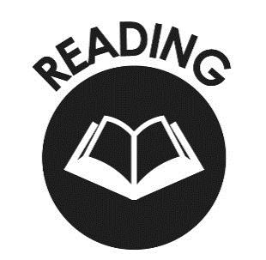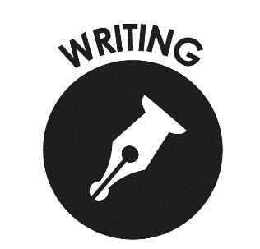

Mathematics

- Compare and order numbers up to 100 and use <
> =.
- Read and write all numbers to 100 in digits & words.
- Say 10 more/less than any number to 100.
- Count in steps of 2, 3 & 5 from zero and in 10s from any number (forwards and backwards).
- Recall and use multiplication & division facts for 2, 5 & 10 tables.
- Recall and use +/- facts to 20.
- Derive and use related facts to 100.
- Recognise place value of any 2-digit number.
- Add & subtract:
  - 2-digit nos & ones
  - 2-digit nos & tens
  - Two 2-digit nos
  - Three 1-digit nos
- Recognise and use inverse (+/-).
- Calculate and write multiplication & division calculations using multiplication tables.
- Recognise, find, name and write 1/3; 1/4; 2/4; 3/4.
- Write and recognise equivalence of simple fractions.
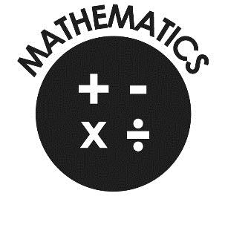
- Tell time to five minutes, including quarter past/to.

End of Year Expectations for Year 2
This booklet provides information for parents and carers on the end of year expectations for children in our school. The National Curriculum outlines these expectations as being the minimum requirements your child must meet in order to ensure continued progress.

All the objectives will be worked on throughout the year and will be the focus of direct teaching. Any extra support you can provide in helping your children to achieve these is greatly valued.

If you have any queries regarding the content of this booklet or want support in knowing how best to help your child please talk to your child’s teacher.

