E4S KS1 Identity - Changing and Growing

Cornerstone: | RSE
Concept: | Identity
Theme: | Changing and growing
Key Questions: | Teachers have used the questions and statements from the E4S curriculum to plan lessons on being safe, which are delivered throughout the year according to the school’s scheme of work.  This is what your child will be learning about in the upcoming scheme of work:  - How have I changed since I was a baby?  - How do we know we are growing?  - How do we feel about growing up?  - What are the correct words for the external parts of the body?  - What are the differences between boys and girls?  - What are the differences between boys and girls bodies?  - What is a stereotype?  - How am I different and similar to other people?  - How are we similar to others?  - In which ways are we all equal?
Questions to consider with your child: | What do you think you were like as a baby?  What happens as we get older?  How do people change?  What do you think you’ll be like when you get older?  How are boys and girls the same?  How are they different?  How can boys and girls be stereotyped?  What can boys and girls enjoy that is the same?
Suggested Resources for parents: | 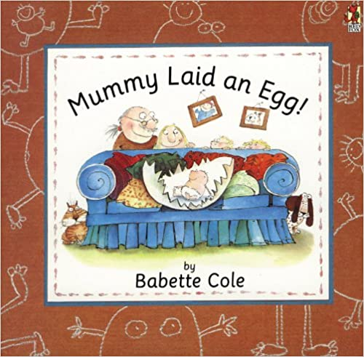  Please find additional support and guidance below in relation to changing and growing.  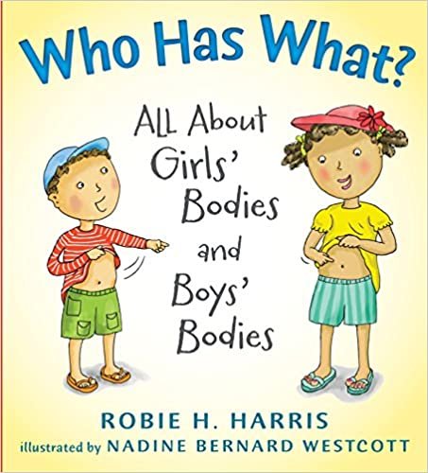  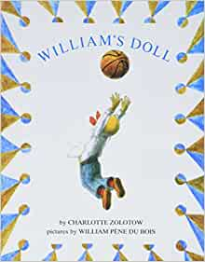  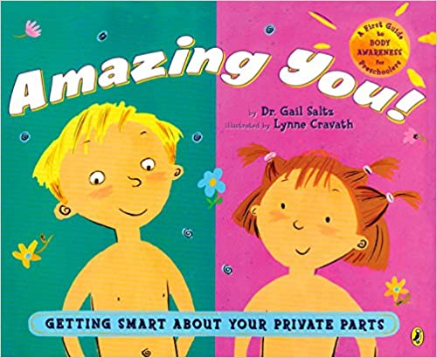  William's Doll  Amazing You!  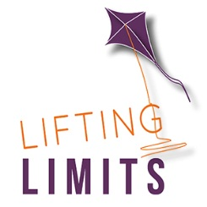  Ada Twist Scientist  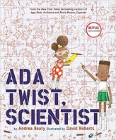  Gender Equality  Mummy Laid an Egg!  Who Has What?

