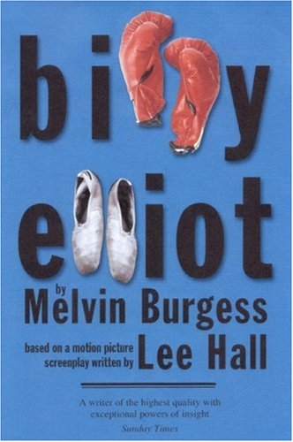
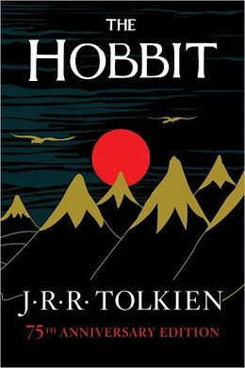
I am taking part in Holy Trinity’s Reading Challenge 2015!

Recommended reading list for Lower Key Stage 3

Title | Author | Parent/carer initials when read
Kit’s Wilderness | David Almond
River Boy | Tim Bowler
Billy Elliott | Melvin Burgess
Tales of the Unexpected | Roald Dahl
The London Eye Mystery | Siobhan Dowd
The Adventures of Sherlock Holmes | Sir Arthur Conan Doyle
The Tulip Touch | Anne Fine
The Thief Lord | Cornelia Funke
The Wheel of Surya | Jamila Gavin
Two Weeks with the Queen | Morris Glleitzman
Secrets of the Fearless | Elizabeth Laird
Skullduggery Pleasant | Derek Landy
Earthsea Quartet | Ursula Le Guin
Love, Aubrey | Suzanne LaFleur
Girl, Missing | Sophie McKenzie
The War of Jenkins’ Ear | Michael Morpurgo
The Wind Singer | William Nicholson
Eragon | Christopher Paolini
A Single Shard | Linda Sue Park
Wolf Brother | Michelle Paver
Truckers | Terry Prachett
Witch Child | Celia Rees
Dakota of the White Flats | Philip Reeve
Time Riders | Alex Scarrow
Cirque du Freak: A Living Nightmare | Darren Shan
Stargirl | Jerry Spinelli
The Hobbit | JR Tolkien
The Sword in the Stone | TH White
A Little History of the World | EH Gombrich
White Fang | Jack London
The Little Prince | Antoine de Saint-Exupery
A Pack of Lies | Geraldine McCaughrean
Wolf Cry | Julia Golding
Ruby Holler | Sharon Creech
Silver Fin | Charlie Higson

(Please record any other titles you have read by these authors on the back)

