E4S KS1 Being Safe - Body Privacy and Saying Yes and No

Cornerstone: | RSE
Concept: | Being Safe
Theme: | Body Privacy and Saying Yes and No
Key Questions: | Teachers have used the questions and statements from the E4S curriculum to plan lessons on being safe, which are delivered throughout the year according to the school’s scheme of work.  This is what your child will be learning about in the upcoming scheme of work:  - How do I keep my body to myself?  - How do I know what is appropriate or not?  - How do I ask for help?  - How do we know when someone wants to keep things private?  - Should we keep everything private?  - How else can we say ‘no’ to being touched?
Questions to consider with your child: | What makes you feel safe?  How does your body tell you that someone is too close or that you feel unsafe?  What can you do if someone touches you and it makes you feel uncomfortable?  Should you always tell if someone makes us feel uncomfortable or unsafe?  Who can you talk to?  Who can you ask for help?  What does private mean?  Should we always keep things private?
Suggested Resources for parents: | 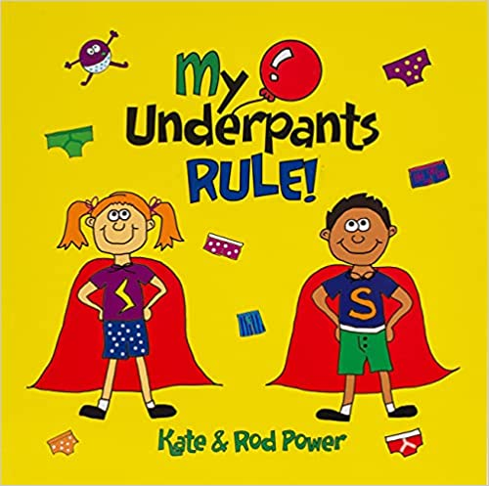  Please find additional support and guidance below in relation to body privacy and saying yes and no.  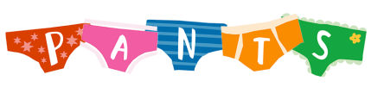  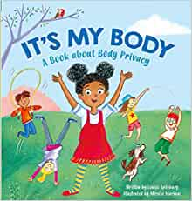  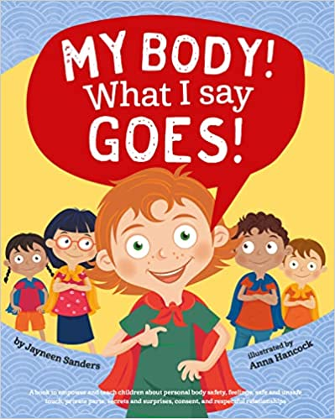  My Underpants Rule!  It's My Body  NSPCC: 'The PANTS rule'  My Body! What I Say Goes!  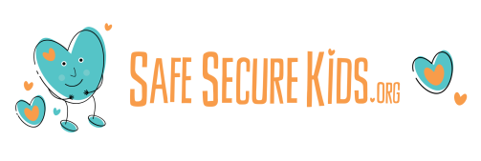  Safe Secure Kids

