Thursday 9th January 2020
Anglo-Saxon Day – Monday 27th January 2020

Dear Parents,
We are looking forward to Sir Teachalot coming in to lead an Anglo-Saxon immersion day in Year 4 on Monday 27th January 2020.
To help the children get into role, we are asking them to dress up as an Anglo-Saxon person. They could be a villager, craftsperson or soldier. Here are some suggestions of what they could wear:
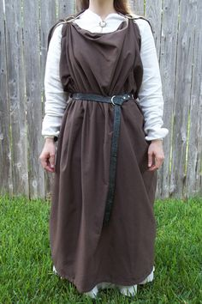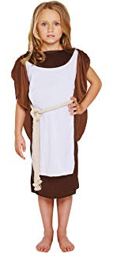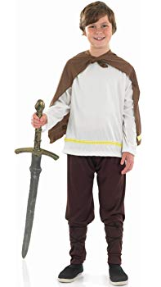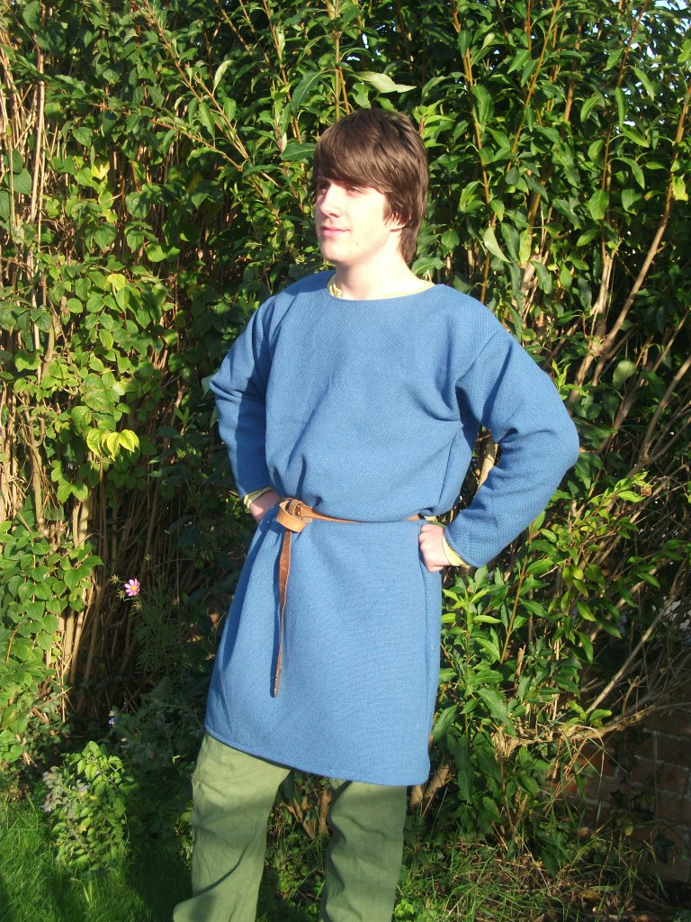
Women wore tunics with brooches to Men wore a tunic with a cloak fastened
fasten them on their shoulders. on the right shoulder with a brooch.

Children will need to come to school dressed as an Anglo-Saxon and will spend all day in their costume, so please ensure they have sensible shoes and will be warm enough to go out at playtimes.

Thank you for your support!

Best wishes
Year 4 Team

