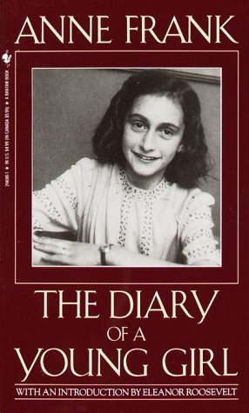
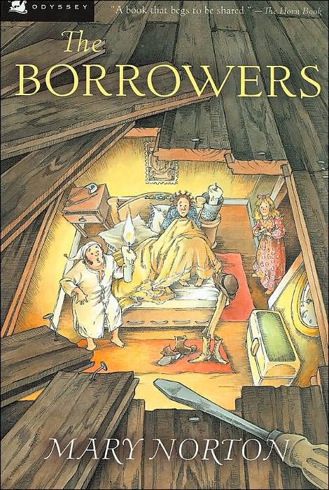
I am taking part in Holy Trinity’s Reading Challenge 2015!

Recommended reading list for Year 6

Title | Author | Parent/carer initials when read
Carrie’s War | Nina Bawden
When Hitler Stole Pink Rabbit | Judith Kerr
Forgotten Voices of the Second World War | Max Arthur
The Diamond of Drury Lane | Julia Golding
Framed | Frank Cottrell Boyce
Millions | Frank Cottrell Boyce
Homecoming | Cynthia Voigt
Noughts and Crosses | Malorie Blackman
Knife Edge | Malorie Blackman
Private Peaceful | Michael Morpurgo
The Secret Diary of Adrian Mole Aged 13 ¾ | Sue Townsend
Treasure Island | Robert Louis Stevenson
Mortal Engines | Philip Reeve
Clockwork | Philip Pullman
Dragon Keeper | Carole Wilkinson
The Curious Incident of the Dog in the Night-Time | Mark Haddon
Peter Pan | JM Barrie
Wizard of Oz | F Baum
Robinson Crusoe | Daniel Defoe
Oliver Twist | Charles Dickens
Jungle Book | Rudyard Kipling
The Railway Children | E Nesbit
The Borrowers | M Norton
The Adventures of Huckleberry Finn | Mark Twain
Alex Rider series | Anthony Horowitz
Anne Frank: The Diary of a Young Girl | Ed. Otto H Frank
Boy Overboard | Morris Gleitzman
Sabriel | Garth Nix
Skellig | David Almond
Awful End | Philip Ardagh
Superfudge | Judy Blume
Assassin | Grace Cavendish
Over Sea, Under Stone | Susan Cooper
The Adventures of Tintin | Herge
Abomination | Robert Swindells

(Please record any other titles you have read by these authors on the back)

