WARDEN PARK ACADEMY TENNIS CAMP SUMMER 2024

Venue - Warden Park Academy - Broad Street Cuckfield.

Age- 4-15 year olds

Time - 9.30-13.00 daily

Dates - Monday 29th July- Friday 2nd August

Cost - £25 a day or £95 for the 5 days

To book on please download the App on the App Store (Sally Turner Tennis)

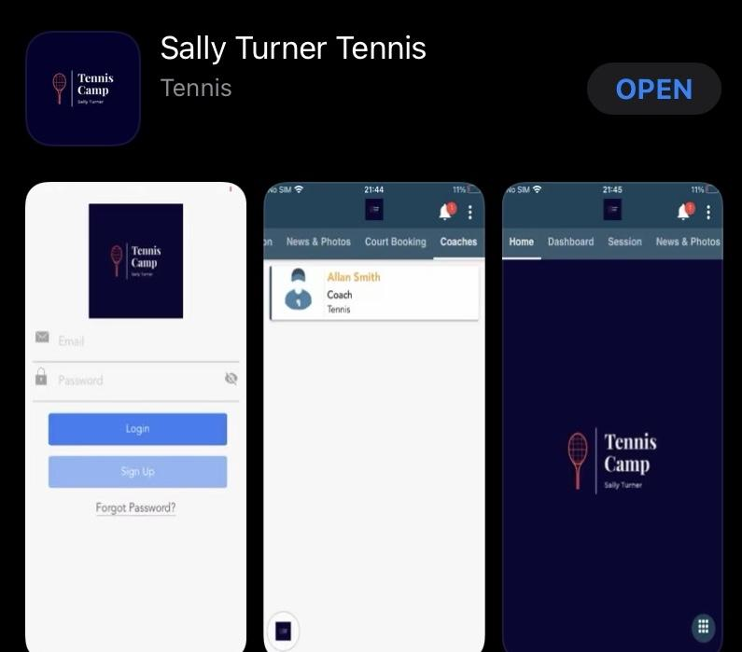

For iOS (iPhones) - https://apps.apple.com/gb/app/sally-turner-tennis/id1562486695

For Android - https://play.google.com/store/apps/details?id=app.activitypro.sallyturner

If you are struggling to use the app please do not hesitate to contact me on sally79turner@gmail.com or 07766006757 and I can help you with how to book onto the camp.

Kind regards

Sally Turner

07766 006757

