

**Lucastes Languages**

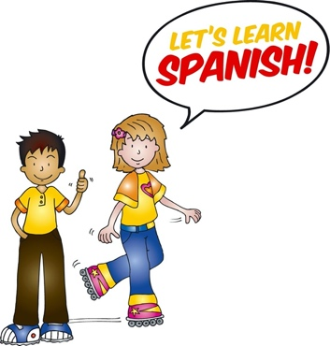42 Lucastes Lane

Haywards Heath

Tel: 01444 457147

Email: [lucasteslanguages@outlook.com](mailto:lucasteslanguages@outlook.com)

**Dear Parents/Carers,**

**¡Hola! Award-winning Spanish club for Year 1 pupils starting September 2024.**

The La Jolie Ronde Spanish Club has been running for several years now at Holy Trinity and has proved to be very successful. With a passion for languages, I strongly believe learning one at a young age provides the children with confidence, an interest in new cultures and a sound grounding for Secondary School.

I teach the award-winning La Jolie Ronde programme; more information about the methodology can be found here: [www.lajolieronde.co.uk](http://www.lajolieronde.co.uk)

In Year 1, the children will follow a programme called ‘Las aventuras de Mifú y Tina y los juguetes’; we accompany the toy characters on different adventures each week.

The programme is designed to enhance the children’s learning skills and to challenge them, in order for them to excel at the language and develop their language skills to the highest level possible, whilst having fun.

**What our classes provide:**

* A unique and well-established structured language course
* An authentic accent for the children to pick up
* Small classes with children of similar age
* A new adventure each week with the toy characters; conversation,

grammar, games, role-plays, rhymes and stories

* Awareness of the foreign country, its geography and culture
* Weeklyfeedback emails and a home link.

Lessons will be held on Mondays from 12.10-12.40, after the children have eaten lunch. The children will be collected from the canteen and returned to the playground for a run-around before afternoon lessons commence.

**Lessons fee:** - Each class costs £6.50 (5% sibling discount).

* One off payment of £20.00 for course book, CD and media link to accompany the class and provide an essential home link.
* Payment required termly in advance (The Autumn term is 12 weeks)

Maximum of 12 children per class to ensure all children get the attention they need.

Minimum number required - 6

If your son/daughter is interested in learning some Spanish, please contact me at the above email address for more information and/or to reserve a space. As soon as I have a minimum of 6 pupils, I will confirm the class will go ahead and provide further enrolment/ payment details. At this stage, you will be required to pay a £20 deposit to reserve a space. The outstanding balance will be due at the start of term in September.

¡Hasta pronto!

Rebecca Miller

Teaching under licence from La Jolie Ronde: Licence no. 21385