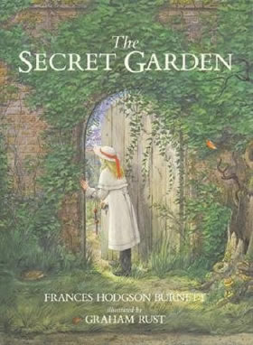
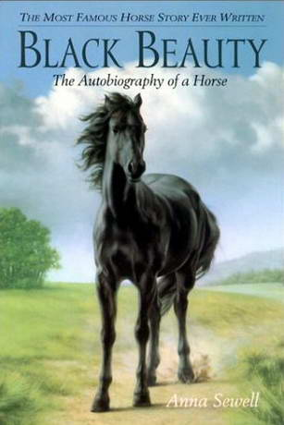
I am taking part in Holy Trinity’s Reading Challenge 2015!

Recommended reading list for Year 5

Title | Author | Parent/carer initials when read
Water Wings | Morris Gleitzman
Blabbermouth | Morris Gleitzman
Belly Flop | Morris Gleitzman
The Diddakoi | Rumer Godden
Stormbreaker | Anthony Horowitz
Walter and Me | Michael Morpurgo
Friend or Foe | Michael Morpurgo
Mister Monday | Garth Nix
Aquila | Andrew Norris
Harry and the Wrinklies | Alan Temperley
The Story of Tracy Beaker | Jacqueline Wilson
Double Act | Jacqueline Wilson
Northern Lights | Philip Pullman
A Christmas Carol | Charles Dickens
Dragon Rider | Cornelia Funke
Journey To Jo’burg | Beverly Naidoo
Journey to the River Sea | Eva Ibbotson
The Owl Service | Alan Garner
Pig Heart Boy | Malorie Blackman
Tom’s Midnight Garden | Philippa Pearce
Watership Down | Richard Adams
The Wizard of Earthsea | Ursula K Le Guin
Wolves of Willoughby Chase | Joan Aiken
Where the Red Fern Grows | Wilson Rawls
Little Women | Louisa May Alcott
The Secret Garden | Frances Hodgson-Burnett
Artemis Fowl | Eoin Colfer
The Wind in the Willows | Kenneth Grahame
Anne of Green Gables | LM Montgomery
Black Beauty | Anna Sewell
Holes | Louis Sachar
There’s a Boy in the Girls’ Bathroom | Louis Sachar
Vicky Angel | Jacqueline Wilson
The Other Side of Truth | Beverley Naidoo
The Turbulant Term of Tyke Tiler | Gene Kemp
Harry Potter series | JK Rowling

(Please record any other titles you have read by these authors on the back)

